PROJECT AND TEAM INFORMATI ON

Project Title
Dynamic Disaster Risk, Evaluation & Rescue Optimization System

Student / Team Information

Team Name:  Team ID: | DisasterX  DSCPP-III-2026-T119
Team member 1 (Team Lead)  (Last Name, name: student ID: email, picture): | Gautam, Parv — 2028562 (Sec. DS2)  2510010701@geu.ac.in  
Team member 2  (Last Name, name: student ID: email, picture): | Rajput, Kashish — 2028444 (Sec. DS1)  251038891@geu.ac.in  
Team member 3  (Last Name, name: student ID: email, picture): | Raunchela, Harsh — 2028723(Sec. ML1)  2510370071@geu.ac.in  
Team member 4  (Last Name, name: student ID: email, picture): | Maurya, Piyush — 2028797 (Sec. ML2)  2510202366@geu.ac.in  

PROPOSAL DESCRI PTION

Motivation
During disasters such as landslides, floods, and earthquakes, roads can become blocked, damaged, or unsafe within minutes, while existing navigation and disaster-response tools continue to suggest routes based on static distance alone. This gap between real-world conditions and route planning can delay evacuation and rescue operations, putting lives at risk. Our project addresses this by treating the disaster-aflected region as a dynamic, weighted graph whose edge weights (risk, traffic, road condition) change in real time as new disaster information arrives. This allows evacuation routes, resource allocation, and hospital/shelter selection to continuously adapt to the actual, changing state of the ground — rather than relying on a fixed, pre-disaster road network. Solving this problem is important because it directly improves response time and safety during high-pressure emergency scenarios where every minute matters.

State of the Art / Current solution
Current solution right now is that we all want a travel from one place to another during any disaster we can get stucked using the apps that everyone are using these days.Those are good for normal days but on a bad they have no information about the route that is blocked or distroyed hours ago.there is not a system or software that takes a decision on point of view of a real person what are we doing is we are building a road network as a graph so when there are changes we just update the area on the graph and the software find a new safe route by itself everytime.

Project Goals and Milestones
Build a C++-based decision engine that models a disaster-affected region as a dynamic graph and makes risk-aware routing, emergency prioritization, and rescue-resource decisions.
Milestone 1 — Core Data Structures
Implement the required C++ structures:
- Graph using adjacency list
- Priority Queue and Min Heap
- Hash Map
- Queue, Set and Stack
Milestone 2 — Core Algorithms
Implement algorithms for routing and graph analysis:
- Dijkstra: Risk-aware route selection
- A*: Route finding using geographic heuristic
- BFS/DFS: Connectivity and reachability
- Bridge/Articulation Point: Identify critical roads and locations
Milestone 3 — Dynamic Engine
Add real-time graph updates for:
- Blocked roads
- Changing risk and traffic
- Emergency prioritization
- Rescue-resource allocation
Routes and rescue plans will be recalculated whenever conditions change.
Milestone 4 — AI/ML Risk Module
Develop a supporting Python ML module using:
- Rainfall
- Soil moisture
- Slope
- Elevation
- Historical data
The generated risk score will be passed to the C++ engine and used in route-cost calculation.
Milestone 5 — Simulation & Frontend
Develop a what-if simulation for road blockages, increasing risk, and unavailable resources.
If feasible, add a Leaflet/OpenStreetMap frontend to visualize roads, routes, blocked areas, and simulation results.

Project Approach
C++ Decision Engine
- Core decision-making engine implemented in C++ using OOP and STL.
- Disaster region represented as a Dynamic Weighted Graph using an adjacency list.
- Vertices: Villages, junctions, hospitals, shelters and rescue stations.
- Edges: Distance, travel time, risk, traffic, road condition and status.
Data Structures
- Graph: Represents the disaster-affected road network.
- Priority Queue: Emergency prioritization.
- Min Heap: Rescue-resource selection.
- Hash Map: Fast ID-based lookup.
- Queue: Incoming disaster-report processing.
- Set: Blocked and visited locations.
- Stack: Path reconstruction and DFS traversal.
Algorithms
- Dijkstra: Risk-aware route optimization.
- A*: Advanced route-finding using geographic heuristic.
- BFS/DFS: Reachability and connectivity analysis.
- Bridge/Articulation Point: Critical-road detection.
AI/ML Support
- Python + NumPy, Pandas and Scikit-learn generate disaster-risk scores.
- Risk scores are passed to the C++ engine as graph weights.
What-If Simulation
- Simulates road blockages, increasing risk and resource unavailability.
- Dynamically recalculates routes and rescue plans.

System Architecture (High Level Diagram)
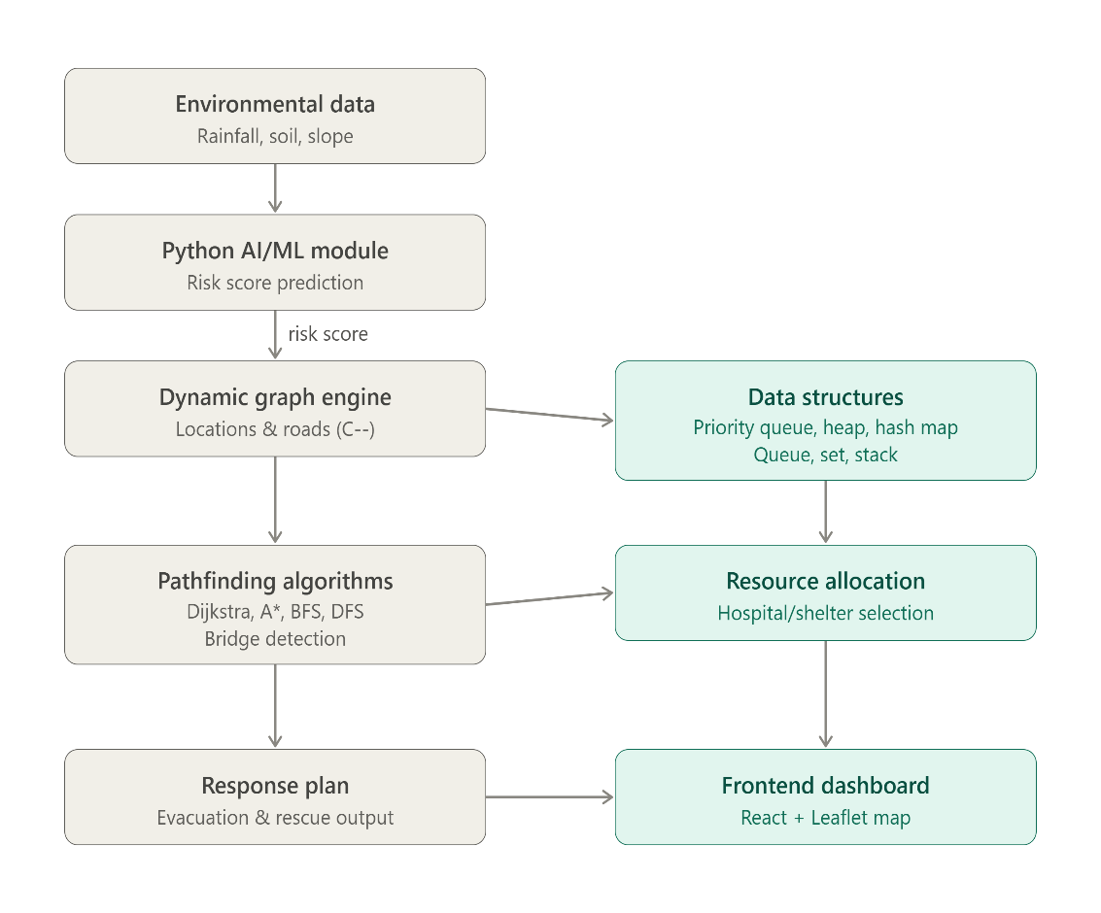

Project Outcome / Deliverables
1) A working C++ decision engine implementing the Graph, Priority Queue, Min Heap, Hash Map, Queue, Set and Stack modules with Dijkstra, A*, BFS, DFS and bridge/articulation-point detection.
2) A supporting Python ML module that generates disaster-risk scores from environmental inputs.
3) A what-if disaster simulation mode demonstrating dynamic re-routing, resource reassignment and updated response plans.
4) An optional map-based frontend (Leaflet/OpenStreetMap) visualizing the road network, routes and simulation outcomes.
5) A final project report and performance comparison (e.g., Dijkstra vs. A*) along with a demonstration video.

Assumptions
The road network, disaster events and sensor readings (rainfall, soil moisture, etc.) are simulated/synthetic for demonstration purposes, since real-time field sensor data is not available. Risk, traffic and road-condition values for a given scenario are assumed to remain constant between successive update events. The underlying road graph is assumed to be connected before a disaster occurs, and all locations (villages, hospitals, shelters, rescue stations) are assumed to have known, fixed coordinates.

References
1) T. H. Cormen, C. E. Leiserson, R. L. Rivest, C. Stein, Introduction to Algorithm, MIT Press.
2) GeeksforGeeks — Graph,
https://www.geeksforgeeks.org
Dijkstra's Algorithm,
A* Search, Priority Queue, Min Heap:
- OpenStreetMap: https://www.openstreetmap.org
- Leaflet.js Documentation: https://leafletjs.com
- Scikit-learn Documentation: https://scikit-learn.org

